**Implementation Of Business Platform**



**Rajshahi University**

**Computer Science & Engineering**

**Department**

**B.S. Engineering Project-1**

**(2017)**

**Session: 2013-14**

**Part-4, Odd Semester**

|  |  |
| --- | --- |
| **Name of the Students** | **Rajob Raihan Monmoy , Jaggesher Mondal** |
| **ID Number** | **14075408,14025423** |
| **Name of the Supervisor** | **Professor Md. Morshedul Arifin** |

NilamHut

Overview

NilamHut is a place where products are sold through Auction. Auctions can be done on previously posted product and also live auction is a part where buyers can attend the auction online.

Scope of the project

The scope of the project is to build an online platform specifically for auction purpose in Bangladesh. It also serves as an E-Commerce platform.

Core Objective

In Bangladesh there are multiple platforms for online selling but there are no platform which implements selling via auction, which is very important for some products. Here is our final goals.

* Auctions can be done on previously posted products.
* Audio and video broadcasting can be performed.
* Real time communication between buyer and seller.
* The application will learn user actions based on the interest they have expressed in the past and judgment they have made by monitoring the choices user makes.
* Secure transaction via NilamHut.

Background Study

* **Local Market**
* There are no auction sites in Bangladesh.
* Selling products on international auction sites is not practical.
* International auctions platforms like beezid[1], wellbid[2] is not available in Bangladesh.
* **International Market**
* International auctions platforms like beezid[1], wellbid[2] does not support real time communication between buyer and seller.
* International auctions platforms like beezid[1], wellbid[2] have not implemented live auction broadcasting yet.
* Most of them do not have preference tracking integrated in their platform.

Feasibility Study

* **Technical**
  + We have experience in ASP.Net Core on backend and Angular on front end.
  + We have also experience on web RTC for real time communication.
* **Economical**
  + There are no competitor site. So benefits are expected to come shortly.
  + NilamHut will charge 5% for each sale. So it is profitable.
  + User can attend or bid on products from anywhere. User don’t have to be there physically.
* **Environmental**
* NilamHut will provide secure transaction.
* NilamHut will prevent frauds.

Application Area

* Government and other organizations like charity organization can use NilamHut for auction.
* General people can also sell their valuable and rare products.
* People can bid online regardless of the place.

Technology to be used

* **Server Side**
  + Language
    - C#
  + Framework
    - ASP.Net Core
  + Database
    - Sql Server
* **Client Side**
  + HTML
  + CSS
  + Bootstrap 4
  + Angular (Angular 4)
* **WebRTC for real time communication.**

Design Step and Implementation

* Design Database for the platform.
* Generate REST API for the application.
* Make Frontend.

The **task list** and require time for this project is given below.

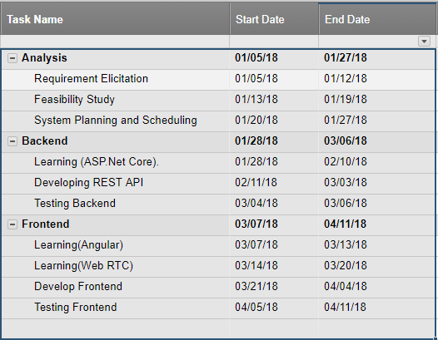

The **gantt chart** for developing the project is given below.

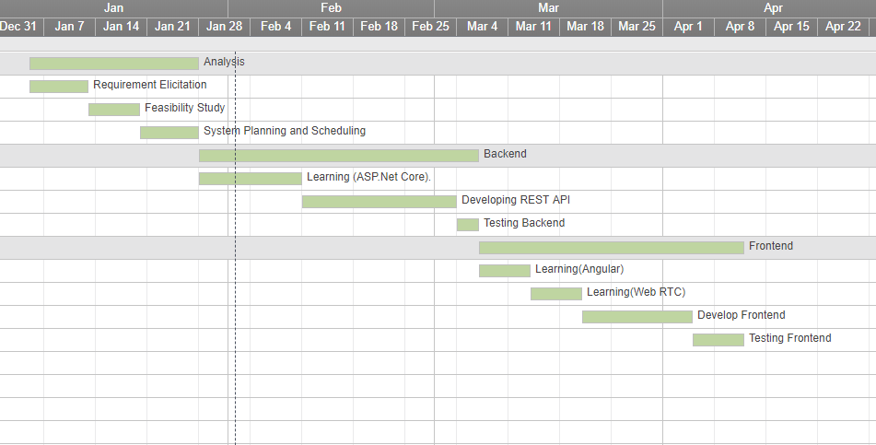

UML Diagram (Use Case)

* General User Use Case:

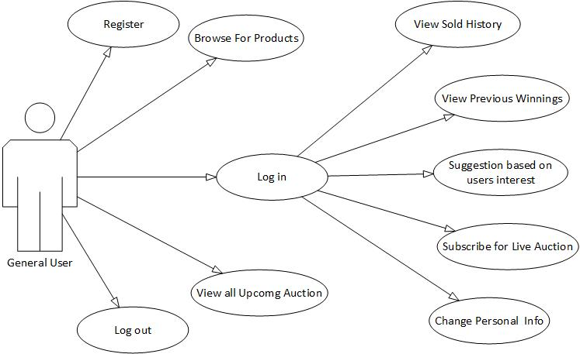

* Buyer Use Case:

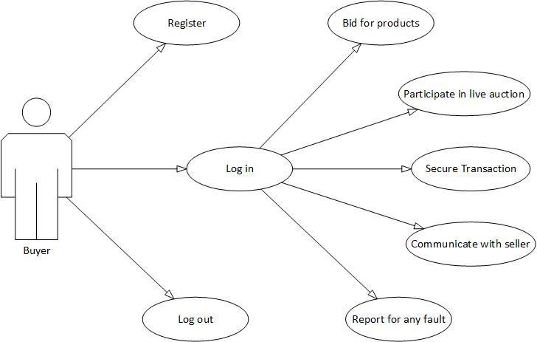

* Seller Use Case:

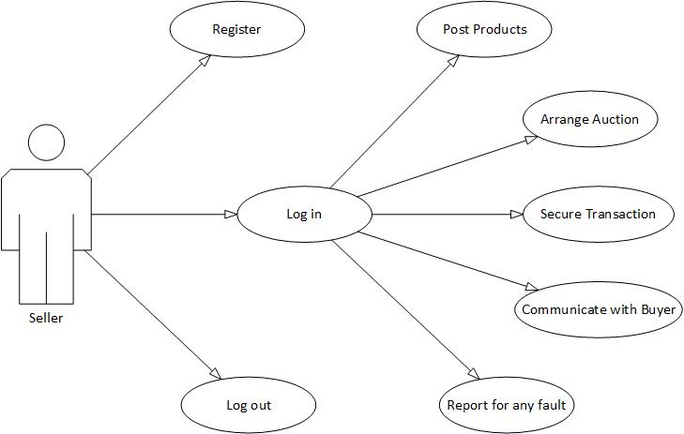

Relational Database(ER Diagram)

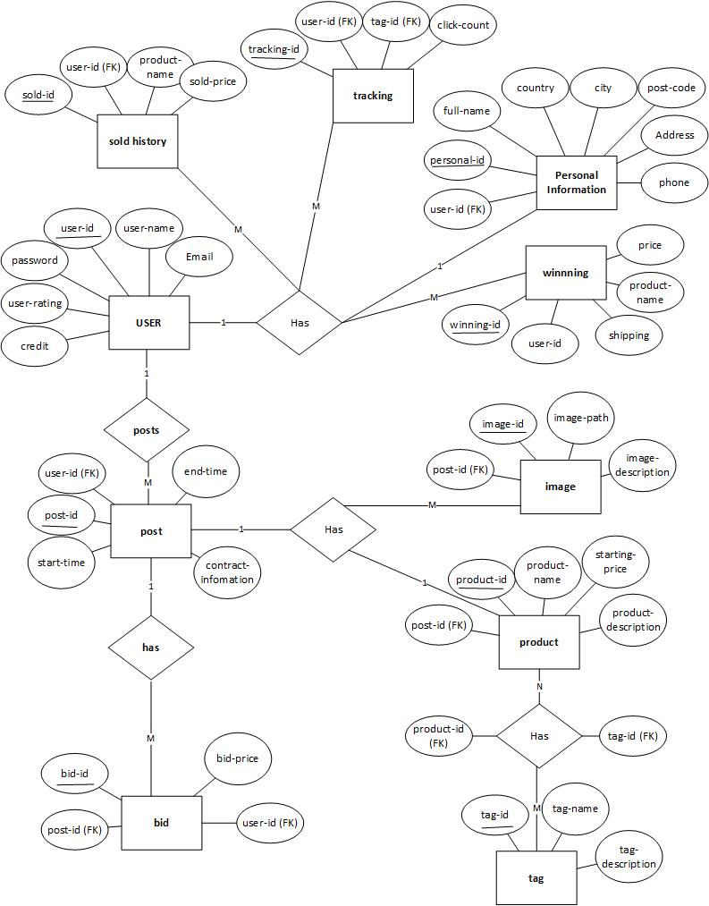

Expected Outcome

* Complete business platform.
* A trustworthy web platform for auctioning rare goods.
* Government and other organizations like charity organization can use NilamHut for auction easily.

Risk Factor

* Asp.net core is very recent technology. So community help is limited.
* Implementing WebRTC in challenging.
* Implementing secure transaction is challenging.

Risk Management

* + Microsoft has very good support for developers.
  + WebRTC has very good community support.
  + Now a days we have mobile banking services like Bkash, Roket. These are practical and easy to implement for Bangladesh.

Reference

[1] <http://www.beezid.com/>

[2] http://www.wellbid.com/

|  |  |
| --- | --- |
| Signature & Date | Signature & Date |
| Rajob Raihan Monmoy  Roll – 14075408  Jaggesher Mondal  Roll - 14025423  Dept. of CSE  University of Rajshahi | **Md. Morshedul Arefin**  Assistant Professor  Dept. of CSE  University of Rajshahi |